Tab 1
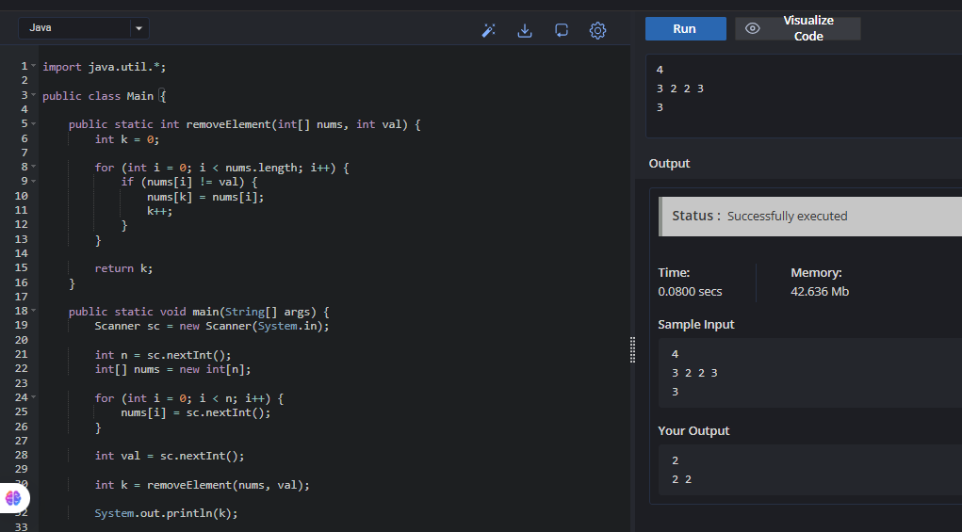WEEK 1

SESSION 1:
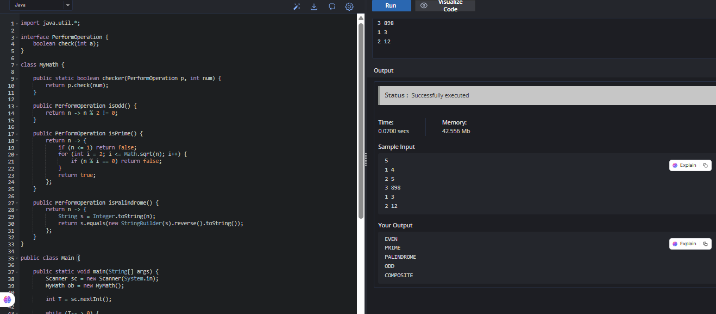
1:JAVA LAMBDA EXPRESSIONS

2:JAVA COMPARATOR
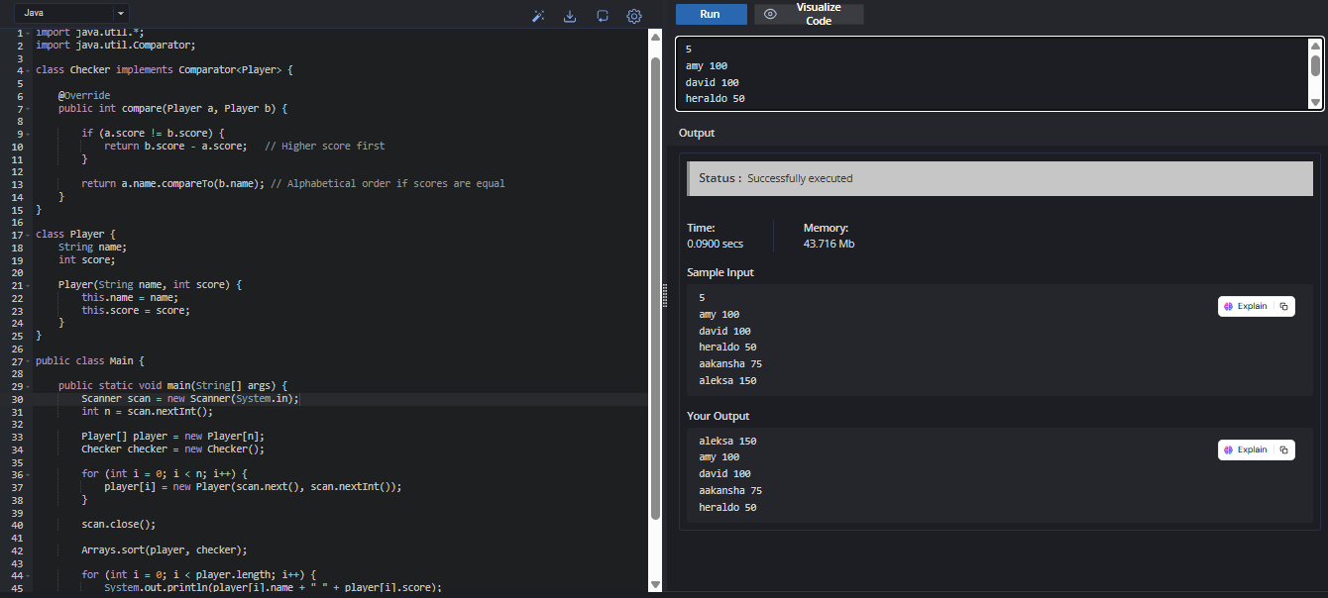

SESSION 2:LAMBDA EXPRESSION
1:JAVA SORT
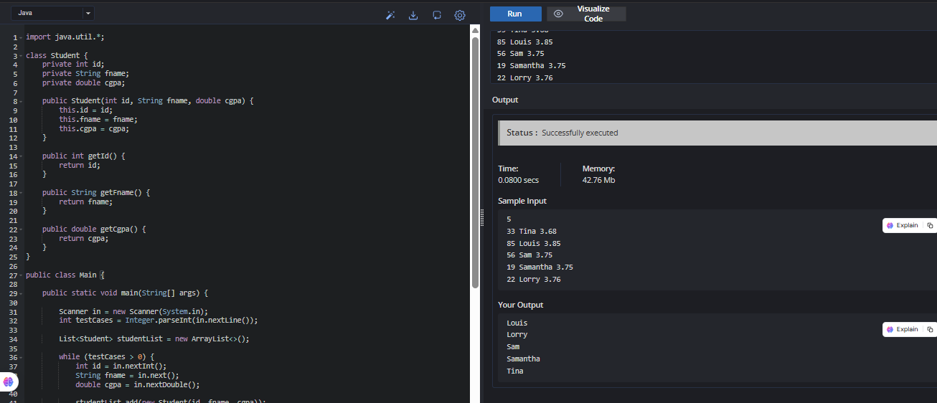

SESSION 3:ANONYNOMOUS FUNCTION AND FUNCTIONAL INTERFACES
1:SORTING:COMPARATOR
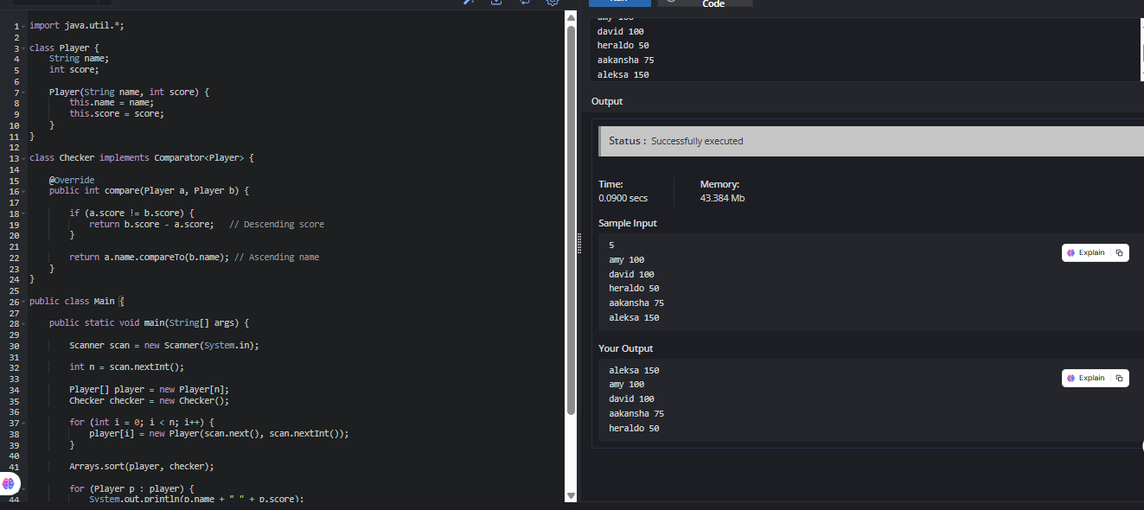
SESSION 4:HIGH ORDER FUNCTIONS

1:RUNNING SUM OF 1D ARRAY
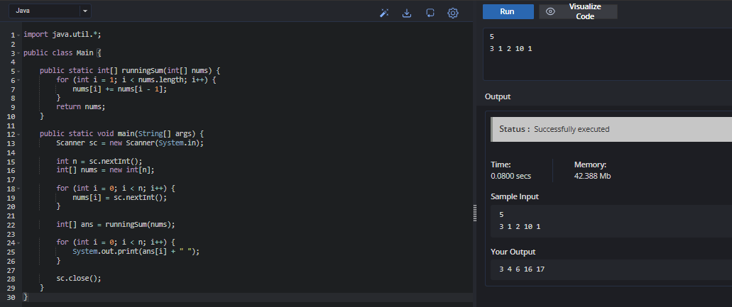

2:RICHEST CUSTOMER WEALTH
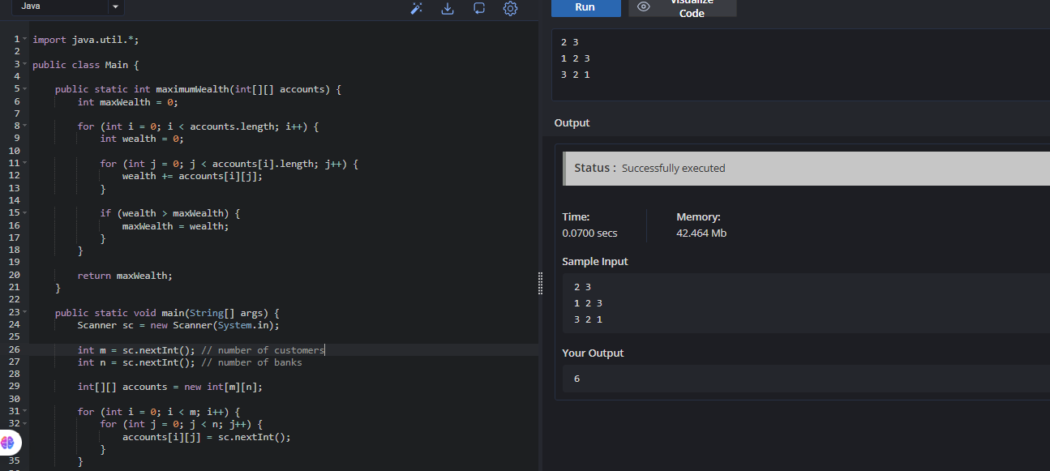

SESSION 5:HIGH ORDER FUNCTIONS
3:SQUARE OF SORTED ARRAY
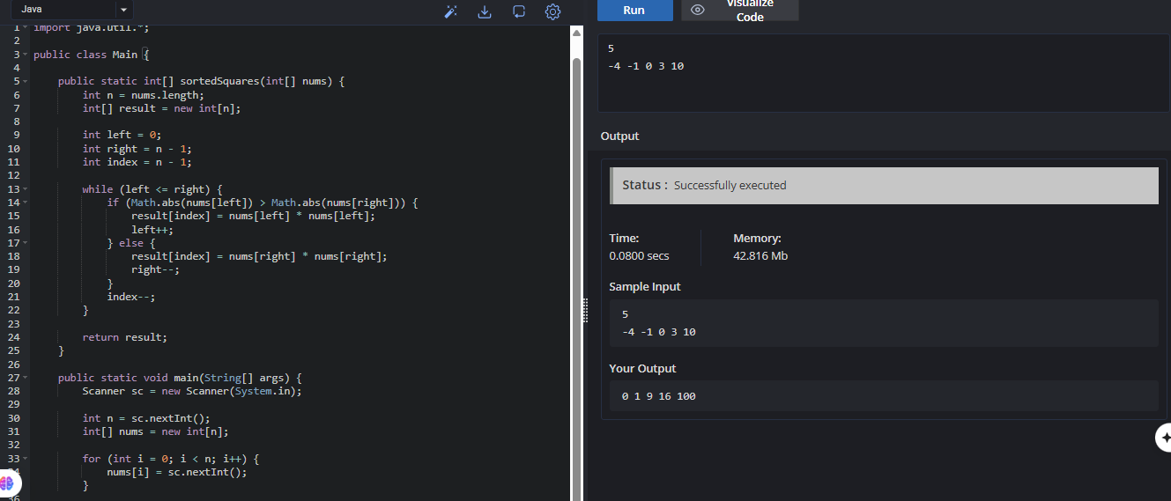

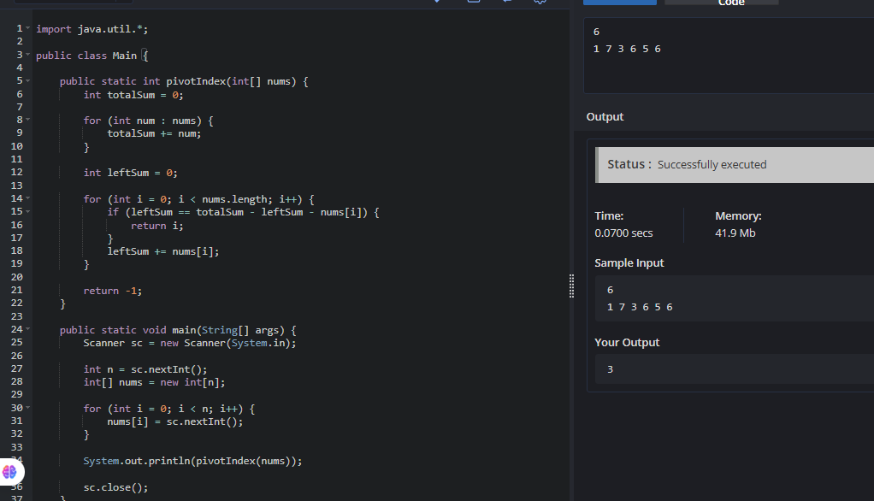
4:FIND THE PIVOT INDEX

WEEK 2:

SESSION 6:FUNCTIONAL PROGRAMING USING map()
1:SHUFFLE THE ARRAY
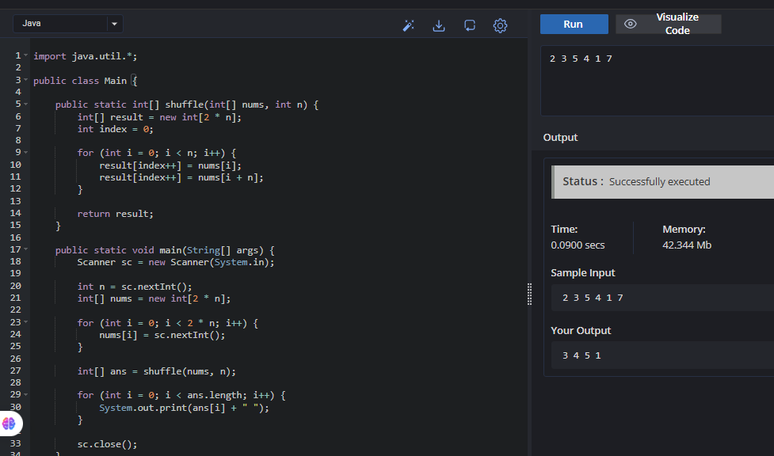
2:BUILT THE ARRAY FROM THE PERMUTATION
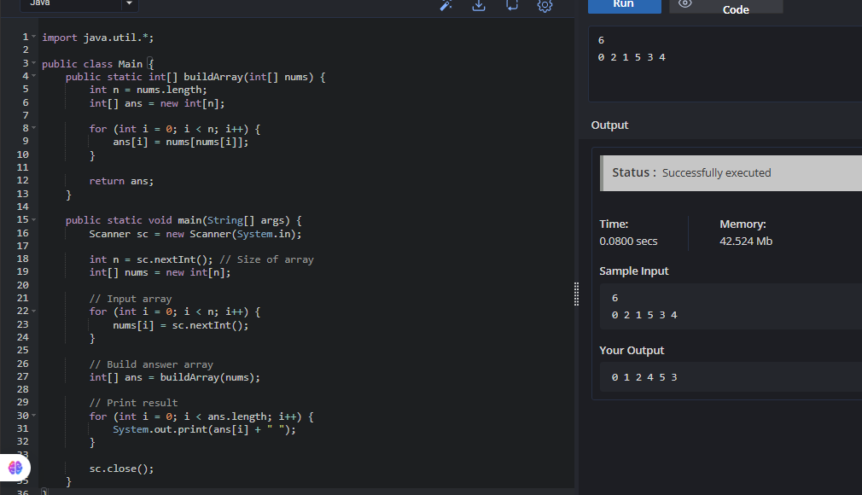

SESSION 7:FUNCTIONAL PROGRAMMING USING filter()
1:REMOVE THE ELEMENT


SESSION 8:FUNCTIONAL PROGRAMMING USING reduce()

Tab 2

